Lynn Landes, Founder, Wild Foodies of Philly, 217 S. Jessup Street, Philadelphia, PA 19107, 215-629-3553 / 714-204-2690 cell / www.WildFoodies.org
June - October 2016: The 5% Vinegar Solution Experiment at Boelsen Cottage, Fairmount Park, Philadelphia, PA (8 pages total)
The purpose of this experiment was to determine if 5% vinegar is effective in the slowing down of targeted plant growth after initial cutback, applications, and follow ups. It is taken for granted that we were not looking for something that stops all growth permanently, as that would constitute a very toxic herbicide. Lynn Landes, founder of the Wild Foodies of Philly was the principal participant in this experiment under a permit from Fairmount Park and the supervision of Park staff.
Observations & Conclusions: 5% Vinegar works very well to stop the growth of most plants. In general, 2 applications of undiluted 5% vinegar, 2 weeks apart, following the die-back by raking, sweeping, and removing the debris, is very effective in controlling plant growth. It is best to start in the Spring, as soon as the plants start appearing. The first application could take twice the amount of vinegar as the second application (after plants start to re-grow). A maintenance schedule should also be implemented, which could entail spot treatments every 3-4 weeks. That maintenance timetable will vary depending on the plant types.
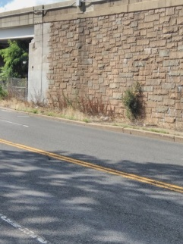
It was our experience that sidewalks needed 1 gallon per 30 square feet per the initial two applications, followed by debris removal. This is more easily accomplished after die-back, compared to pulling out live, intact plants. If the plants are not pulled, regrowth occurs and soil builds up much more quickly (see photo on left).

As with Roundup, the vinegar not only killed the roots, but also bleached the leaves of all the treated plants, including English Ivy. The exception to this rule is Japanese Knotweed, which requires a much more aggressive approach. This is accomplished best by using 5% vinegar early in the Spring when the shoots first appear, and repeating applications as needed, in addition to eventually digging out the plants manually. Knotweed stalks that are treated with vinegar do die back and the root structure is considerably weakened, but then new shoots appear. Therefore, manual removal is necessary.

In the case of steep landscapes, the use of any defoliant will encourage erosion, if not reseeded immediately. In my experience, allowing steep hillsides to go wild is the best protection against erosion.

It should also be noted that an herbicide was used on the outside of the sidewalk and along the slope in front of the cottage. Also, according to Fairmount Park staff, it appears that the sidewalk around the cottage was sprayed with an herbicide this Spring, but the plants have grown back regardless. Therefore, if an herbicide was used, it seems that it was no more effective than 5% vinegar. Roundup claims to keep regrowth for a period of months, which was not our observation, however they are also credited with creating super weeds and contain extremely toxic chemicals that adversely impact human health and the environment. For health information on products like Roundup and how some countries and states are avoiding its use, see: http://www.healthalertphilly.org/ToxicFreeParks.htm.

In conclusion, we endorse 5% undiluted vinegar as a safe and effective herbicide, and oppose products like Roundup which are hazardous to people and the planet.

5% Vinegar Treatment Protocol: For initial application and follow-up treatments
- Select warm dry weather
- Cut back plants to just above the soil
- Immediately apply vinegar, best done in early evening between 7-8 pm to prevent rapid evaporation
- Two weeks after each application, rake, sweep, and otherwise remove the debris
- Maintenance spot treatments or re-application as needed
Experiment Documentation:
- Location # of the experiment
- Types of plants to be treated
- Dates of vinegar application
- Gallons of vinegar applied
- Rate of regrowth: + / ++ / +++
- Photo diary of the locations
Locations of Experiment:
#1 location: north side of cottage, on MLK Drive end
- 20”-40”: poison ivy
- 40”-64”: mugwort
- 64”-83”: pokeweed
#2 location: north side of cottage, on driveway end / 83”-134”: Japanese knotweed targeted only, other bushes remain
#3 location: west side of cottage, ¾’s of center sidewalk - leading from driveway toward house (34 rows of bricks + slate) / 12’ feet: various plants
#4 location: curb from center sidewalk toward horse stable / 12’ feet: various plants
#5 location: remainder of sidewalk, west and south sides of cottage, except for east side of cottage
#6 location: east side of cottage, facing MLK Drive

2016 DATA TABLE: CUT BACKS AND APPLICATIONS (Sidewalks needed 1 gallon per 30 square feet per the initial two applications.)
Notes:
* next to dates of application - vinegar in gallons
* rates of re-growth: slow + / medium ++ / fast +++
# 1 LOCATION - north side of cottage, on MLK Drive end
PLANT(s) | Jun 25 (1 gal) | Jul 19 (1/2 gal ) | Aug 19 (1/2 gal)
mugwort | ----------------- | + | +
poison ivy | ----------------- | + | +
pokeweed | ----------------- | + | +

# 2 LOCATION – : north side of cottage, on driveway end, but applied to knotweed only,
PLANT | Jun 25 (2 gal) | Jul 7 (2 gal) | Jul 19 (2 gal) | Aug 3 (2 gal) | Aug 15 (1gal) | Aug 27 (1 gal) | Sep 19 (2 gal)
J. knotweed | ---------------- | +++ | +++ | +++ | ++ | ++ | +++

# 3 LOCATION – west side of cottage, ¾’s of center sidewalk - leading from driveway toward cottage
PLANT | Jun 25 (1 gal) | Jul 7 (2 gal) | Aug 3 (1 gal) | Aug 21 (1 gal) | Sep 6 (1 gal)
various | ------------- | + | + | + | +

# 4 LOCATION – curb from center sidewalk toward horse stable
PLANTS | Aug 7 (1 gal) | Aug 21 (1 gal)
various | --------- | +

# 5 LOCATION – remaining sidewalk on west and south side of cottage
PLANTS | Aug 15 (17 gal) | Aug 27 (8 gal)
various | ---------- | +

# 6 LOCATION – east side of cottage, facing MLK Drive
PLANTS | Aug 15 (5 gal) | Sep 6 (5 gal)
various | ---------------- | +

PHOTO DIARY: Location 1 – north face of house
Jun 25, 2016 (2 gal) | Jun 28, 2016 | Jul 7, 2016 (2 gal) | Jul 19, 2016 (2 gal)
before cutback & application |  |  | re-application
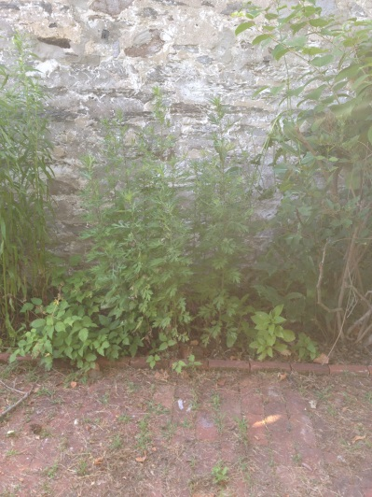 | 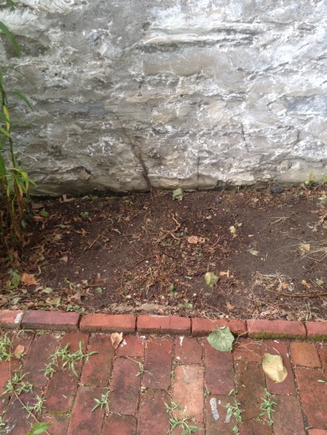 | 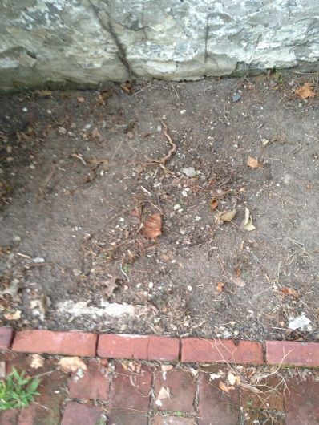 | 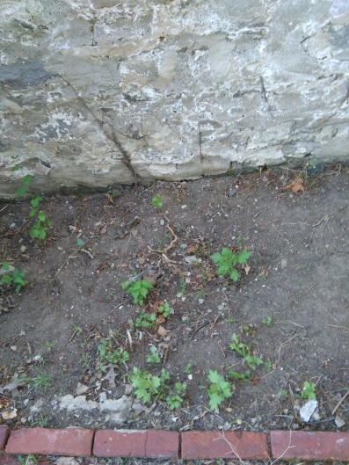
Jul 31, 2016 | Aug 15, 2016 (1/2 gal) | Sep 19, 2016 (2 gal) | Oct 19, 2016
clean-up | re-application |  | clean-up
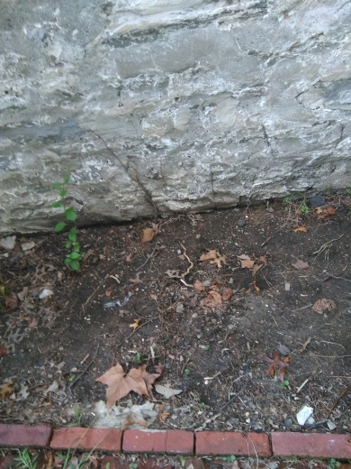 | 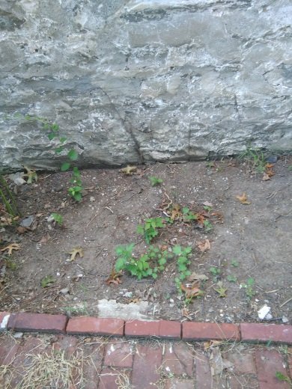 | 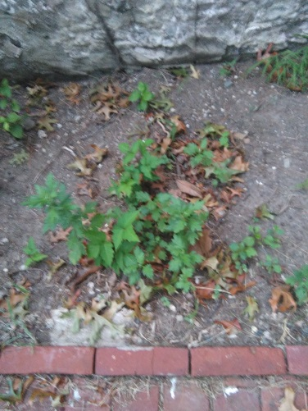 | 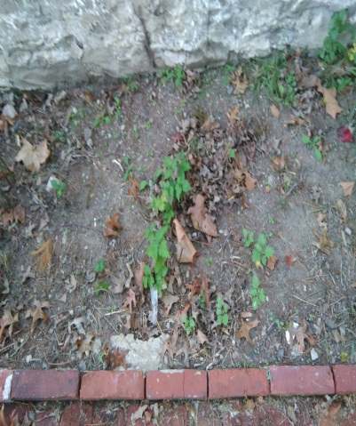

PHOTO DIARY: Location 2 – Japanese Knotweed, north face of house
June 25, 2016 (2 gal) | June 28, 2016 | July 7, 2016 (2 gal) | July 19, 2016 (2 gal) | Aug 3, 2016 (2 gal)
before cutback & application | clean-up | cutback & reapplication | cutback & reapplication | cutback & reapplication
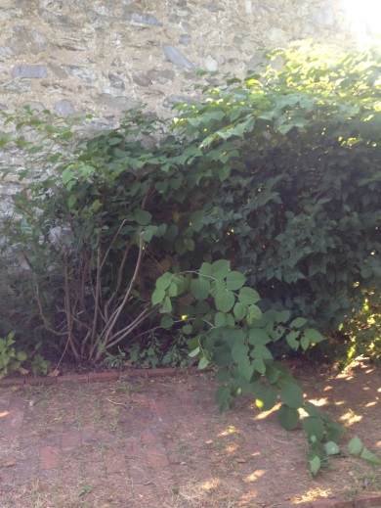 | 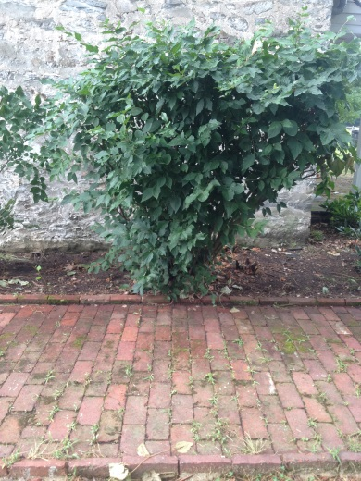 | 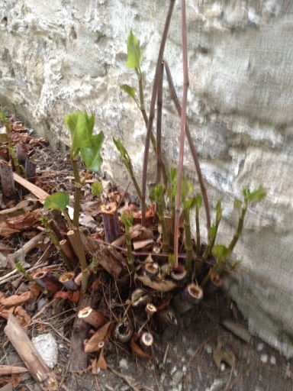 | 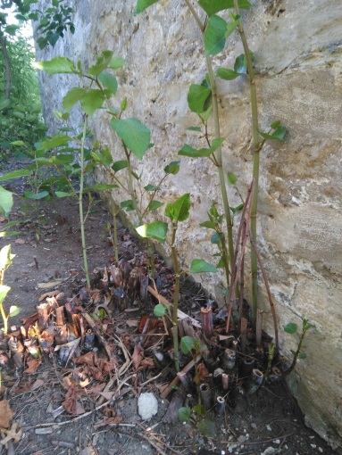 | 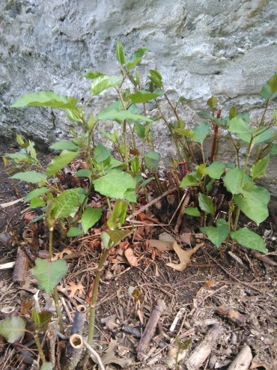
Aug 15, 2016 (1 gal) | Aug 27, 2016 (1 gal) | Sep 6, 2016 | Sep 19, 2016 (2 gal)
cutback & reapplication | cutback & reapplication | cutback
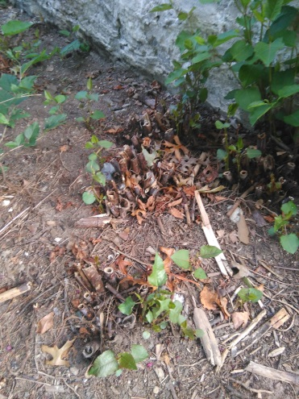 | 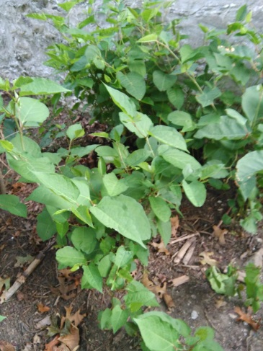 | 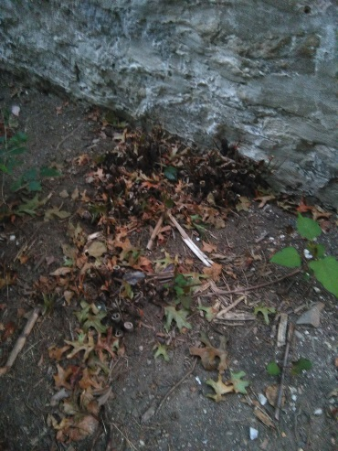 | 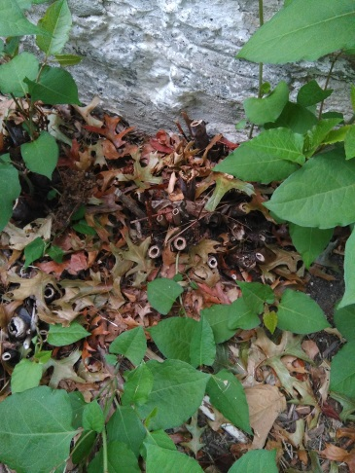

PHOTO DIARY: Location 3 (partial front sidewalk)
June 25, 2016 (1 gal) | June 28, 2016 | July 7, 2016 (2 gal) | July 19, 2016 | Aug 3, 2016 (1 gal)
No cutback, after application |  | re-application | clean-up | re-application on
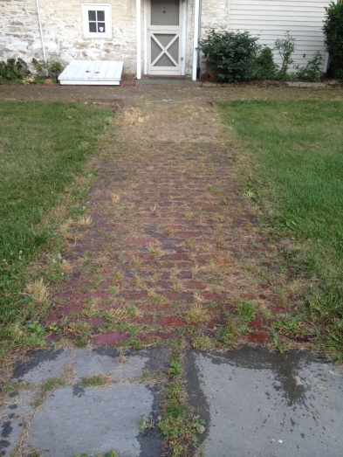 | 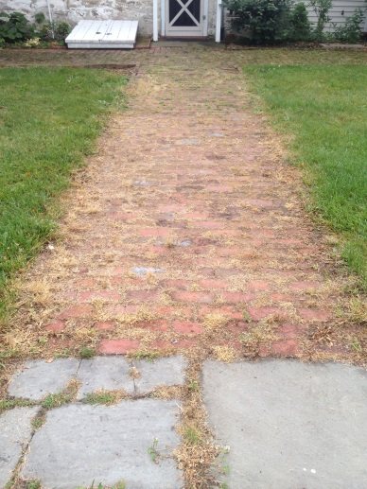 | 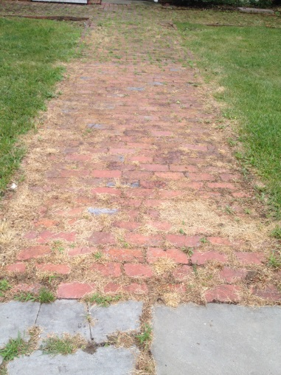 | 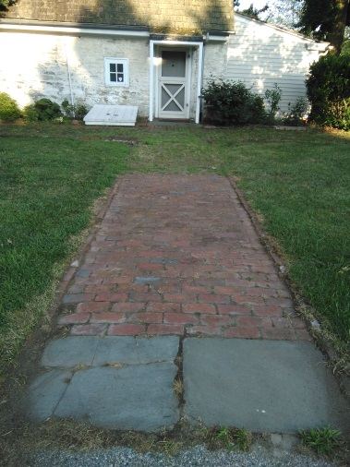 | 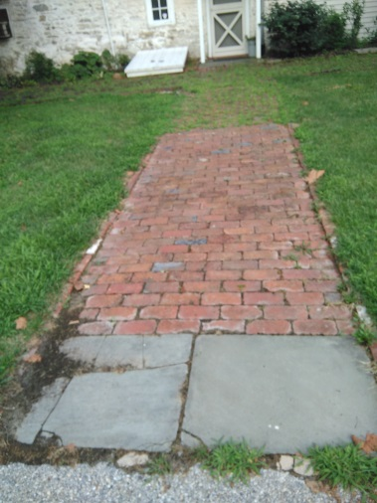
Aug 21, 2016 (1 gal) | Aug 27, 2016 | Sep 6, 2016 (1 gal) | Sep 18, 2016 | Oct 18, 2016
re-application | clean-up | re-application | clean-up
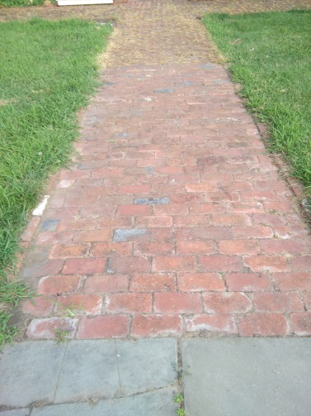 | 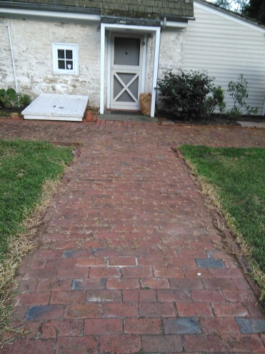 | 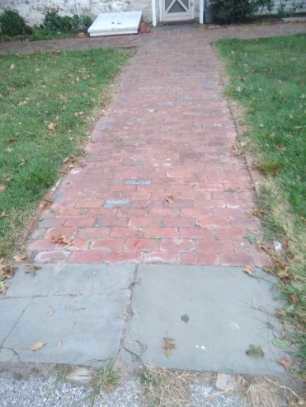 | 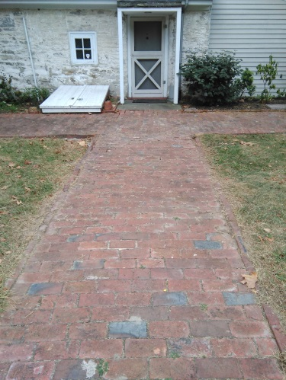 | 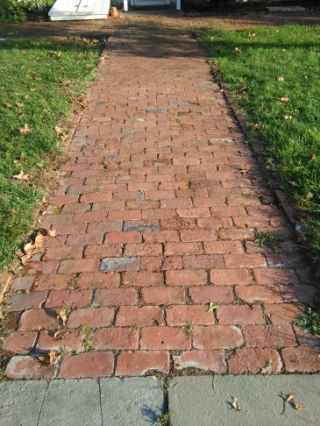

PHOTO DIARY: Location 4 (curb)
Aug 7, 2016 (1 gal) | Aug 21, 2016 (1 gal) | Sep 6, 2016 | Sep 18, 2016
no cutback, before 1st application | re-application | clean-up | clean-up
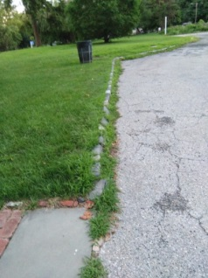 | 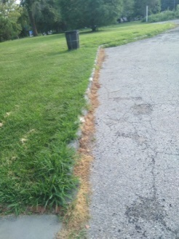 | 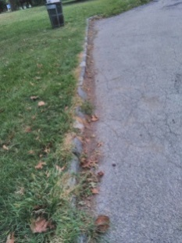 | 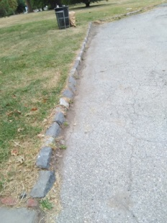
PHOTO DIARY: Location 5 (remainder of front and side sidewalks)
Aug 15, 2016 (17 gal) | Aug 21, 2016 (8 gal) | Sep 6, 2016 | Oct 18, 2016
12 days after 1st application | re-application) | clean-up
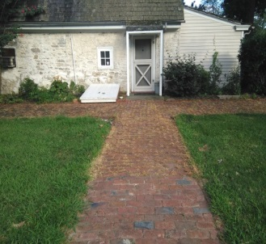 | 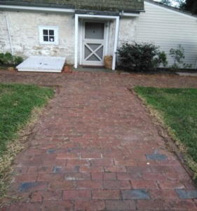 | 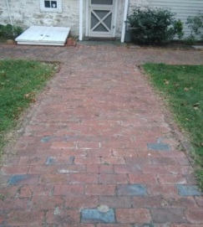 | 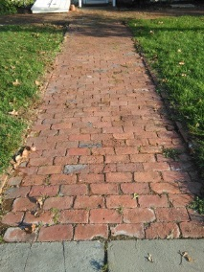
PHOTO DIARY: Location 6 (back sidewalk, facing MLK Drive)
Aug 15, 2016 (5 gal) | Aug 27, 2016 | Sep 6, 2016 (5 gal) | Sep 18, 2016 | Oct 19, 2016
1st application |  | re-application | clean-up | clean-up
(no photo taken) | 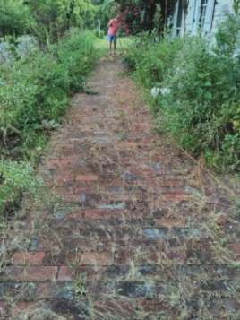 | 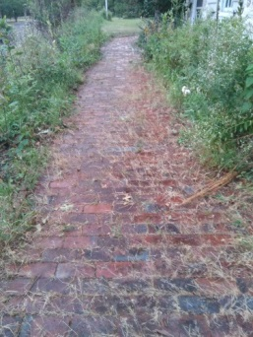 | 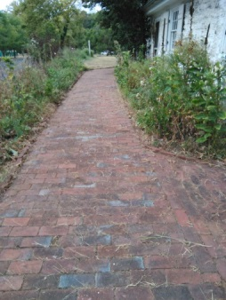 | 